UNIQUELY AUSTRALIAN WEBSITE SITE MAP

ABOUT
- Project Participants
- Governance
- Advisory Board

FOOD AND PRODUCTS
- Herbs and spices
- Native nuts
- Wattle seeds
- Native fruits
- Kakadu plum
- Native honey
- Native seaweed
- Kangaroo

INDUSTRY
- Our industry participants
- Social and indigenous participation
- Composition and sensory quality
- Food safety and toxicity
- Bioavailability and nutritional quality
- Trademarking and benefit sharing
- Propose an idea

RESEARCH
- Study with us
- Work with us
- Our projects

PUBLICATIONS
- News
- Research publications
- Fact Sheets
- Resources
- FAQ

COMMUNITY
- Resources
- Outreach
- Schools
- News & Events

NEWS AND EVENTS
- News
- Events

CONTACT
- Telephone & Email
- Social media contacts
- Query form
- Map [Coopers Plains]

ABOUT
The ARC Training Centre for Uniquely Australian Foods aims to transform the native Food and Agribusiness Sector through development of selected crops, foods and ingredients using an Indigenous governance group to oversee the process of converting Traditional Knowledge into Branded Products.
This project is supported by the Australian Government through the Australian Research Council's Industrial Transformation Training Centre funding scheme (project IC180100045), the Department of Agriculture and Fisheries and the University of Queensland.
Native foods represent a major opportunity for premium Australian products in both domestic and export markets, capitalising on consumer interest in the provenance and traditional heritage characteristics of foods.
Expected outcomes include technical information to support branding and market development, best practice development in social factors and legal arrangements for benefit sharing, and a cohort of trained and industry-ready researchers who can lead the native foods industry forward. This should provide significant benefits in driving sustainable growth of the premium Australian food sector with high value products which can never be imitated due to their unique origins and properties.

Logos: ARC, UQ, ANFAB, Kindred Spirits, Karen Sheldon Catering, BeeInventive Pty, Venus Shells

Project Participants [page for each participant]
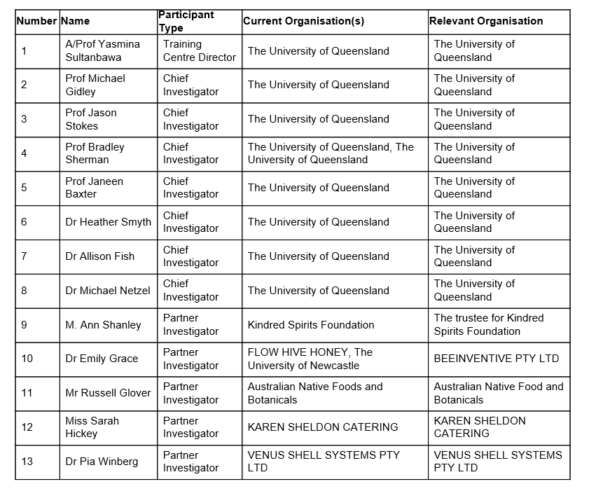

COMMUNITY
Converting traditional Indigenous ethnobotanical knowledge into branded products
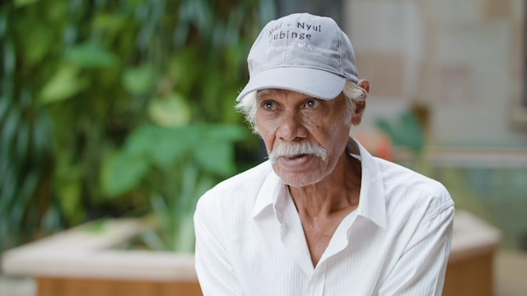
[video Bruno] [Video Madonna]
The Centre will tackle the broad question of how to develop sustainable premium food and ingredient industries based on unique characteristics of Australian native plants and animals such as kangaroo.
- Developing sustainable business models involving all stakeholders by identifying social factors and beneficial Indigenous participation across the value chain from raw material to finished foods,
- Identifying the characteristic sensory properties that provide uniqueness and justify premium ingredient and product market positioning,
- Defining any safety and toxicity issues sufficient to facilitate access to major global markets,
- Characterising the nutritional value of ingredients and products for premium applications.

[Map of Australia]
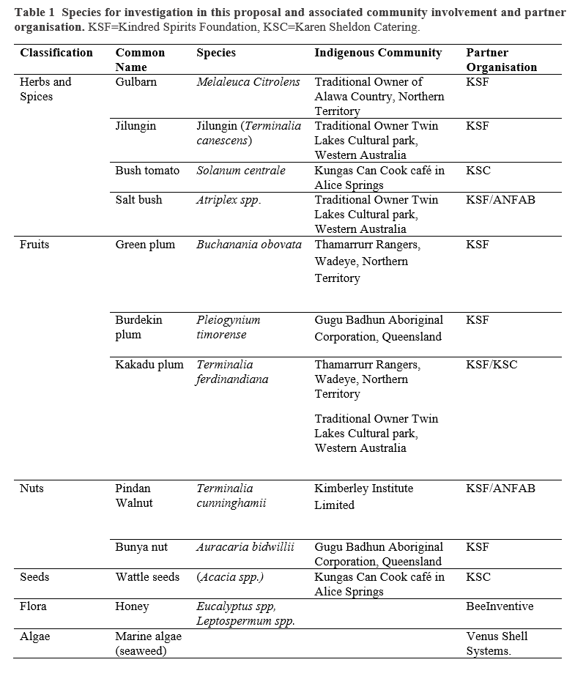

INDUSTRY
The outcomes of the Training Centre will include the testing of market opportunities, the development of appropriate social and business models, and the identification of future opportunities for Uniquely Australian Foods. Economic and quality of life benefits through job creation and benefit sharing arrangements will be secured for Indigenous communities through sustainable business models which will help to Close the Gap, and the development of supply chain partnerships to reduce the risks involved in taking products to market.
Our industry participants:
- Kindred Spirits
- ANFAB
- Karen Sheldon
- Beeinventive Pty Ltd
- Venus Shell Systems

Native foods to be studied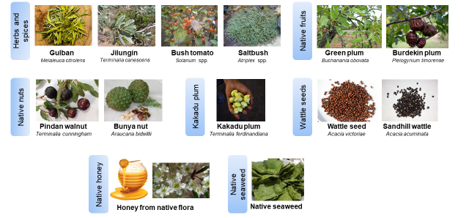
Provenance
Branding

RESEARCH

- Study with us
- Career opportunities
- Our projects
- Research showcase (links to profiles of individual researchers)

- 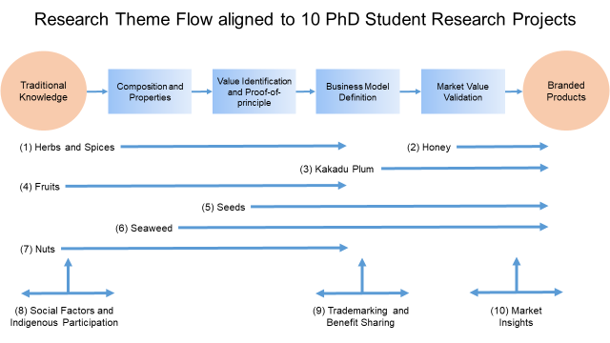

PUBLICATIONS

- News
- Research publications
- Fact Sheets
- FAQ

CONTACT
- Telephone & Email
- Social media contacts
- Query form
- Map [Coopers Plains Brisbane]

